A
SUMMER INTERNSHIP PROJECT
ENTITLED
TITLE: “ ”

SUBMITTED BY
MR./MS

GUIDED BY
DR/MR/MRS
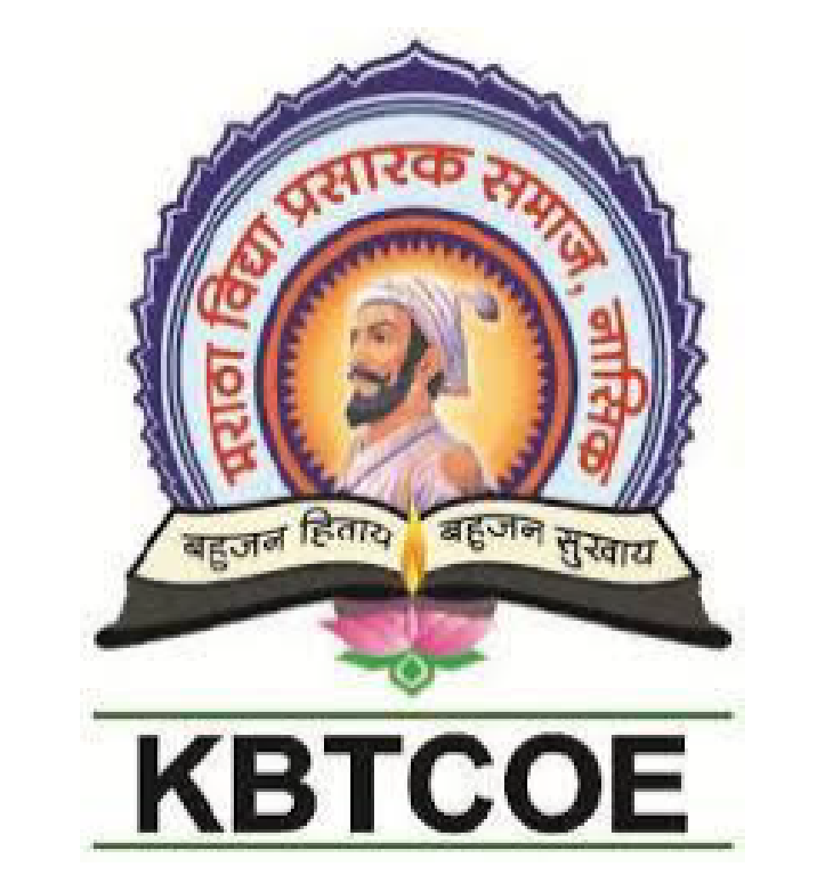
DEPARTMENT OF MBA
MARATHA VIDYA PRASARAK SAMAJ’S
KARMAVEER ADV.BABURAO GANPATRAO THAKARE
COLLEGE OF ENGINEERING, NASHIK-013
2024-25

DEPARTMENT OF MBA

CERTIFICATE

This is to certify that Mr./Ms has successfully completed the Summer Internship Project entitled
TITLE: “ ”
.
Under the guidance of
Dr./Mr./Mrs.

In the partial fulfillment of the requirement of MBA Course (2024 Pat) as expected by Maratha Vidya Prasarak Samaj’s Karmaveer Adv.Baburao Ganpatrao Thakare College of Engineering, Nashik during the Academic Year 2024-25.

Dr./Mr./Mrs. Dr.D.T.Khairnar Dr.S.R.Devane
Project Guide Head of Department Director

DECLARATION

I student of MBA First Year at Maratha Vidya Prasarak Samaj’s Karmaveer Adv. Baburao Ganpatrao Thakare College of Engineering, Nashik, hereby declare that the Desk Research Project entitled: “ ” is my original work and has been carried out under the guidance of Dr./Mr/Mrs.
I further declare that this project is submitted in the partial fulfillment of the requirements of the MBA Course (2024 Pat) for the Academic Year 2024-25. The information presented and the data analyzed in this project are true to the best of my knowledge and understanding.
This project has not been submitted to any other institution or organization for the award of any degree, diploma, or certificate. I take full responsibility for the authenticity and originality of the content provided in this project.

Place: Nashik
Date: Mr./Miss.

ACKNOWLEDGEMENT

I express my sincere gratitude to Maratha Vidya Prasarak Samaj’s Karmaveer Adv. Baburao Ganpatrao Thakare College of Engineering, Nashik, for providing me with the opportunity to undertake the Desk Research Project entitled “ ” as part of the partial fulfillment of the MBA Course (2024 Pattern).
I am deeply indebted to Dr./Mr./Mrs., my project guide, for their invaluable guidance, continuous encouragement, and insightful feedback throughout the course of this project. Their expertise and mentorship have been instrumental in shaping the direction and outcomes of this study.
I also extend my heartfelt thanks to Dr. D. T. Khairnar, Head of Department, for their support and facilitation, as well as Dr. S. R. Devane, Director, MVP’s KBT COE, Nashik for their visionary leadership and the resources provided to ensure the smooth progress of this project.

Mr./Miss.:

